All in one (single page for both **admin** and **user/subscriber**) Login page

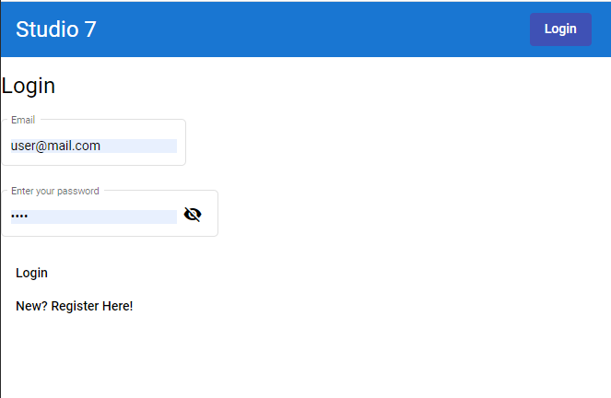

Logged in with User credentials Dynamic toolbar and content page with search bar at the top

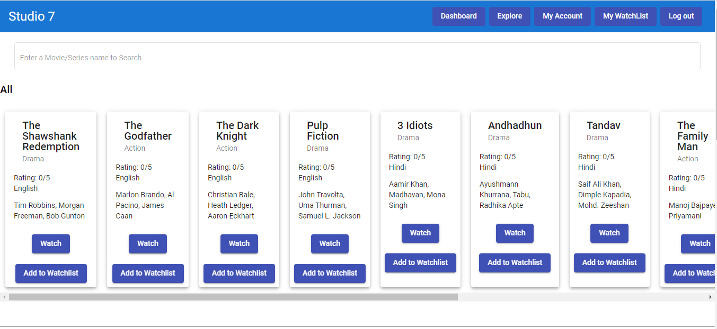

Items added in the watchlist

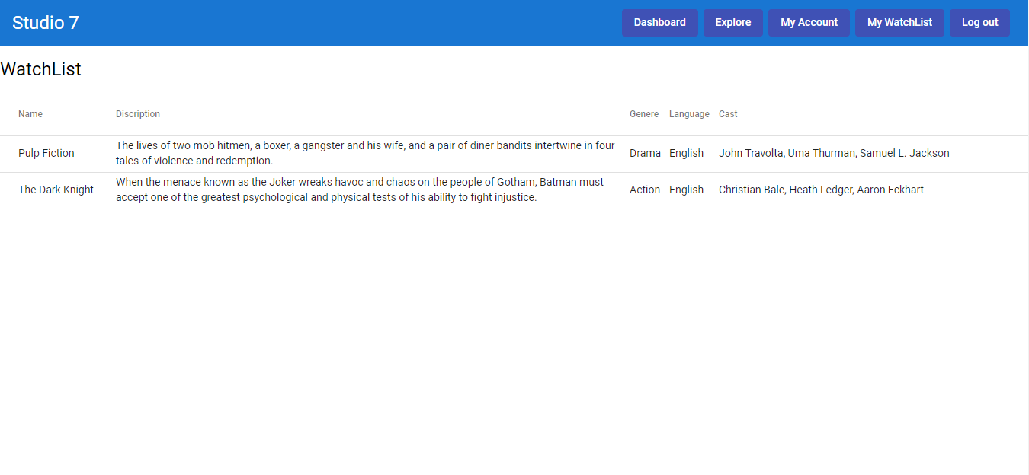

Explore tab with filters on top

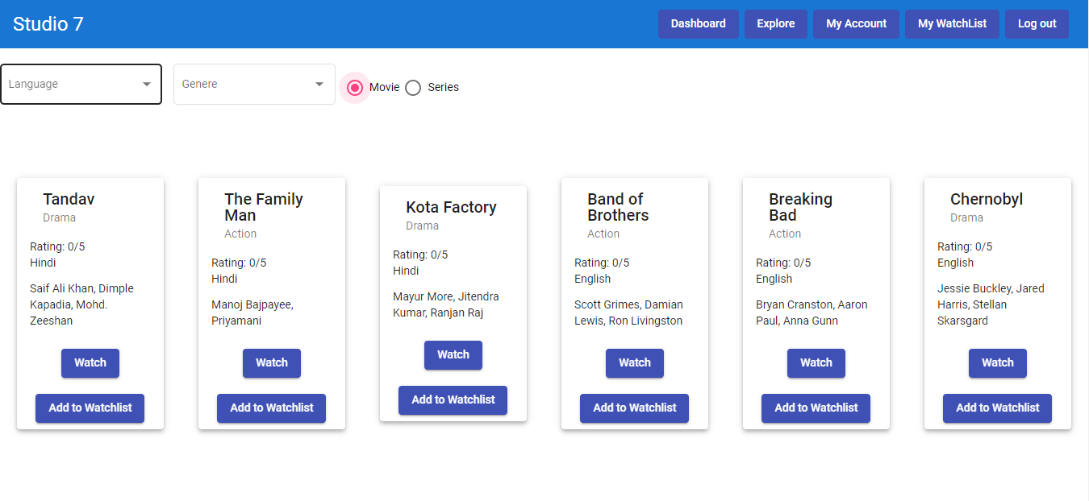

Watch or update Account details

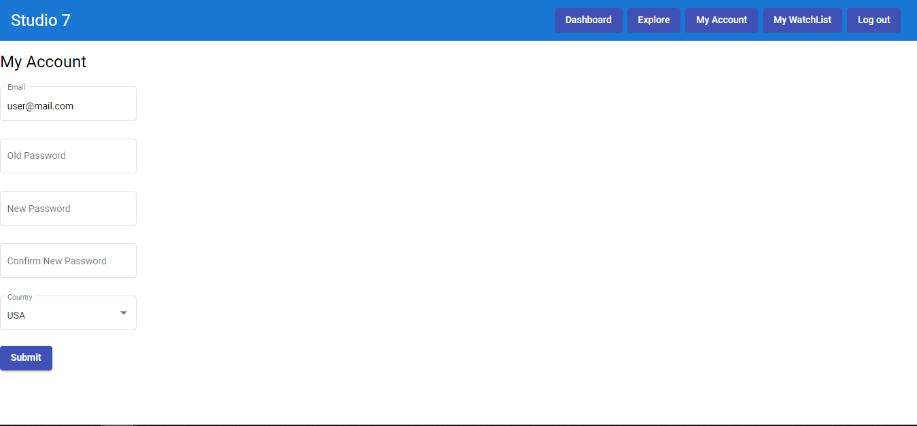

Content Pop up for watching trailer, playing the content containing details about that content and an input for user rating. Can be sent an email to recommend someone

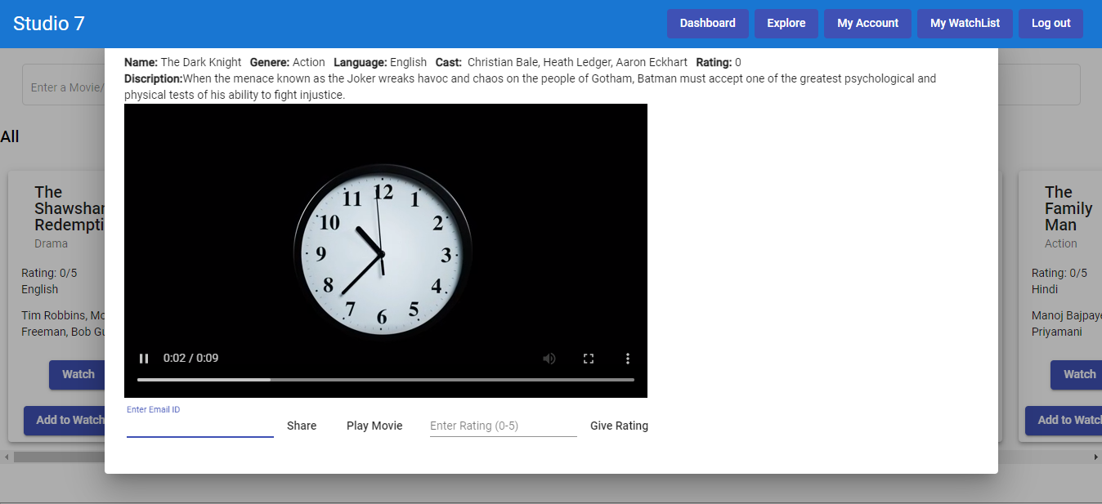

Register as a new User/Subscriber – notice the eye in the password box to verify the password

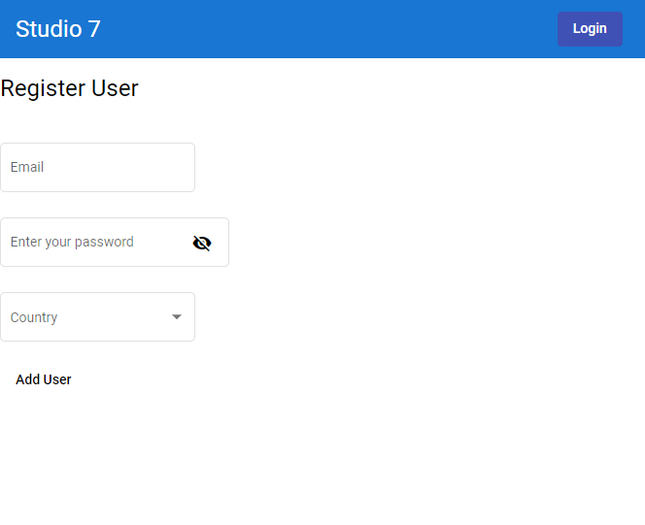

Login as Admin

List of subscribers with all in one filter box – can filter via country or admin status etc.

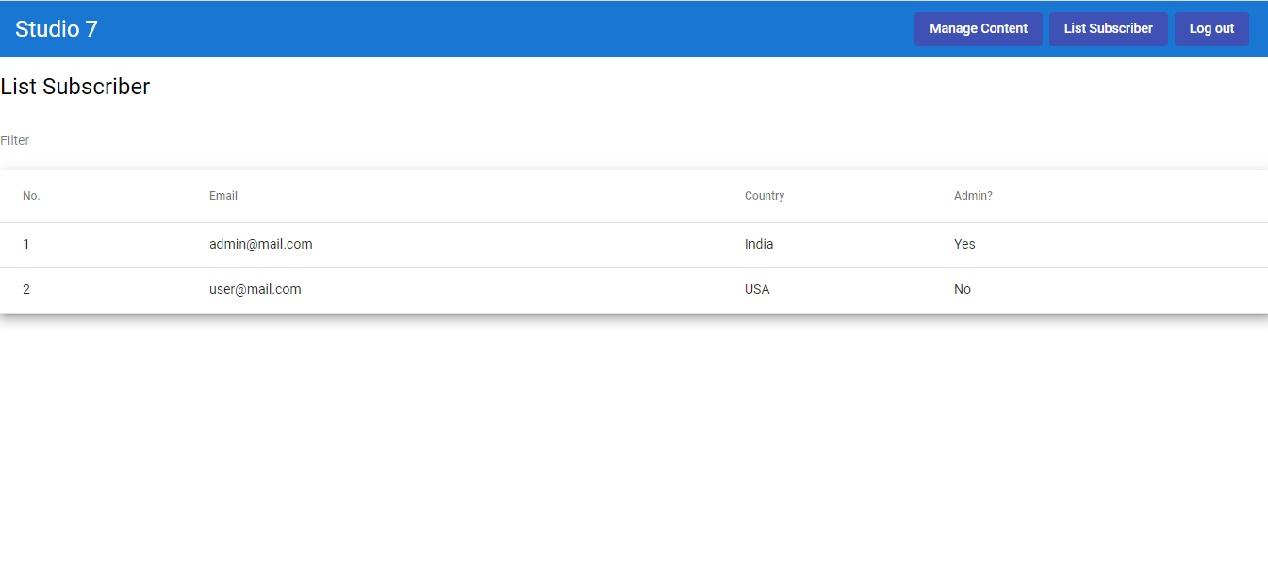

Manage content tab for Admin. It has Add content option as well as several filter option, Update and delete content option

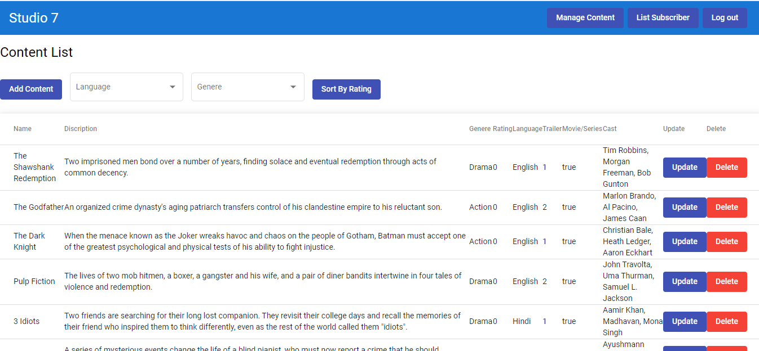

Filtered content list

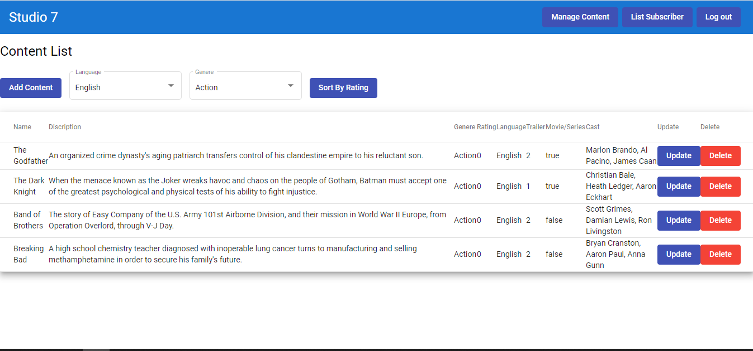

Add new content

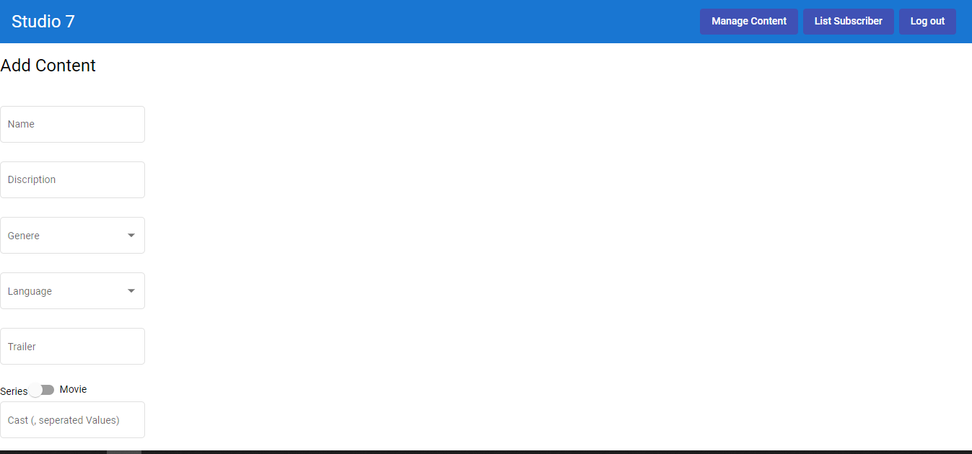

Update existing content

